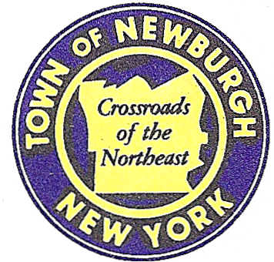

TOWN OF NEWBURGH
--------Crossroads of the Northeast _
OLD TOWN HALL
308 GARDNERTOWN ROAD NEWBURGH, NEW YORK 12550

PLANNING BOARD
JOHN P. EWASUTYN, CHAIRMAN TELEPHONE 845-564-7804
FAX 845-564-7802
E-MAIL: planningboard@townofnewburgh.org

PLANNING BOARD AGENDA

APRIL 3, 2014

**PLEASE NOTE: The Planning Board Meeting will start at 7:00 P.M. and all Applicants/Representatives are to be present at that time. The Meeting will be held in the Meeting Room of Town Hall, located at 1496 Route 300, Newburgh NY.**
- Volkswagen of Newburgh (2013-11)  Route 17K and McDonald Street  Sec. 95; Blk. 1; Lot 53  Zone: IB  Rep: Dominic Cordisco, Esq.  Drake, Loeb, Heller, Kennedy,  Gogerty, Gaba & Rodd, PLLC  555 Hudson Valley Avenue, Suite 100  New Windsor, New York 12553 | SITE PLAN
- Magyar Service Center (2011-04)  5465 Route 9W  Sec. 9; Blk. 1; Lots 3 and 6  Zone: B  Rep: Frank Valdina, PE  Valdina Consulting Engineers  4 Pleasant View Avenue  Newburgh, NY 12550 | AMENDED SITE PLAN
- Cassara Subdivision (2014-06)  442 Fostertown Road  Sec. 17; Blk.2; Lot 32.12  Zone: AR  Rep: Mercurio-Norton-Tarolli-Marshall  P.O. Box 166  Pine Bush, NY 12566  - WTF NY Lot Line Change (2014-07)  979 & 983 NYS Route 32  Sec. 2; Blk. 1; Lots 42 & 46  Zone: RR  Rep: Charles Brown, P.E.  Talcott Engineering Design, LLC  1 Gardnertown Road  Newburgh, NY 12550 | SITE PLAN  INITIAL APPEARANCE  LOT LINE CHANGE  INITIAL APPEARANCE
*WORK SESSION: Project Readiness Discussion scheduled for 5:30 p.m. in the Meeting Room of Town Hall on Thursday, April 3, 2014*

